Student Name: _________________________

Step 1: Log In to The AET
Go to http://www.theaet.com, and log in by choosing:
Information needed is:
  - Chapter Number: A two-digit state abbreviation “+” FFA Chapter number. Example, TX0765
  - Username: Typically first initial and last name, but your teacher will provide. Example, VKirby, (Vanessa Kirby)
  - Password: At first, this is the same as your username. A custom password can be created in the Student profile.

  - If your teacher inputted your Google Email when creating your account will you be prompted to login with your Google Account

Student Login Information
Our Chapter Number is: | My username is: | My password is:

Step 2: CHOOSE PROFILE: Complete
About You, Your Activities & Your Interest - Check off these important steps as you complete each one (a,b,c…)!
ABOUT YOU SECTION:
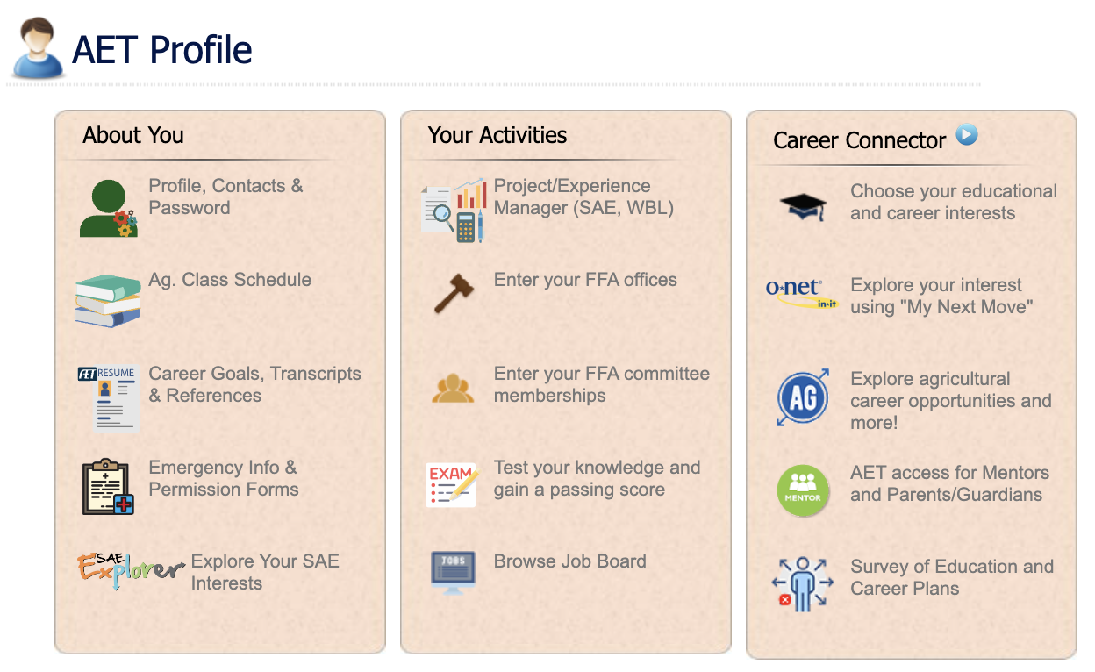
__ a. Manage/Edit your personal profile & password – this is an important step to complete all sections.
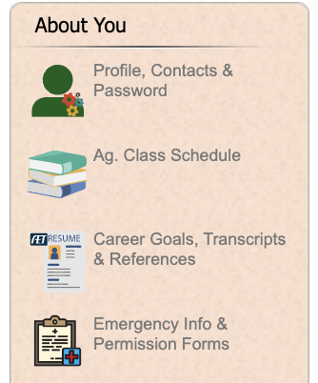
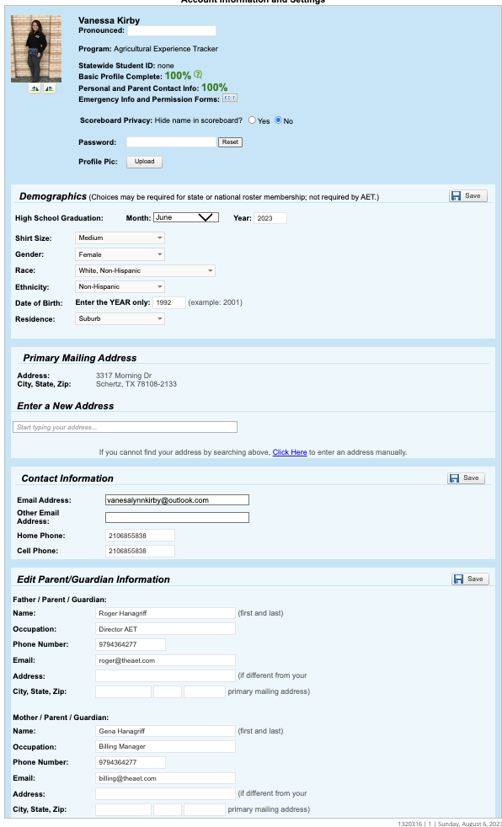
Enter your complete address (choose “Click Here” to manually enter if it does not populate the dropdown
Complete contact information & verify your email address.
Your goal is 100% complete, so do all required sections
Complete all sections and hit Save as you go

*once complete choose PROFILE and continue to the next section
__ b. Record your class schedule - through choosing “add a class” and is essential to keep records! If your class is not listed, be sure to ask your teacher to setup their courses
__ c. Career Goals, Transcripts & Referenences – The resume builds from record book information, but be sure to list (1) accomplishments or certifications, (2) career objective and (3) references, (4) Upload your transcript (if applicable)
__ c. Emergency Info & Permission Forms – Profile Information will flow into this page and you can enter your emergency contact information. You will also add your medical/dental conditions and allergies. Choose 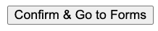 and you can send an eletronic waiver for your parent/guardian to sign via email!
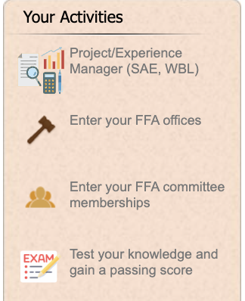
YOUR ACTIVITIES SECTION:
__ d. Experience Manager (SAE/WBL) – This is where SAEs (project learning) are developed; see “Selecting an SAE/WBL and Creating the Experience” Guide for details.
__ e. Enter your Leadership roles – List your leaderships
__ f. Enter your committee memberships – List leadership committee involvement and work on your chapters strategic plan
__ g. Test your Knowledge & Gain Passing Score – Find all exams on AET here, Parli Pro, Tractor Safety, and exams added by your teacher(s)!
YOUR INTEREST SECTION:
__ h. Choose your educational & career interest – Select careers that interest you and rank them on the right side.
__ i. Explore Careers using O-Net – explore your career interest and learn more about educational needs, personality traits, salaries, and job demand.
__ j. Explore Ag Careers using Ag Explorer – explore your Ag Career Interest on a website managed by FFA.org.
__ k. Access for Mentors and Parent/Guardians – you can add a person that is mentoring or reviewing your records. This allows them a “read only” access to your record book.
__ l. Survey of Education and Career Plans – finish this six-question survey reviewing your post-secondary interest and plans

Each of these maybe grades, so be complete and share your results with your teacher

What is next?

- Learn more about SAEs through www.exploresae.com and choose the SAE that is right for you and your educational/career interest
- Learn more about your SAE project setup and records in student help (part of your AET system)
- Track your time experiences in the JOURNAL and any monetary investment in the FINANCES section.

You are Ready for Records!

